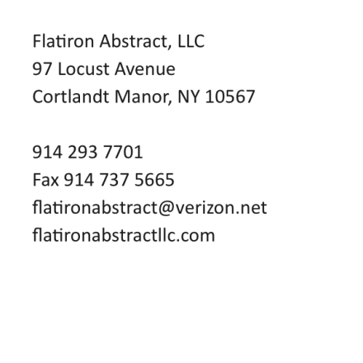


NEW YORK ESTATE TAX AFFIDAVIT

Title No.

STATE OF NEW YORK :
: ss.:
COUNTY OF __________ :

__________, being duly sworn, deposes and says:

1. I reside at __________.
2. I am the Executor/Administrator of the Estate of __________ who died a resident of __________ County, on the __________ day of __________, 20___.

If neither of the above, state relationship to decedent: __________.
3. I am fully familiar with the assets of which the decedent died seized, which comprise the gross estate as hereinafter defined, and said gross estate is less than $__________ and therefore said estate is not subject to any New York Estate Tax. (See Notes Below)
4. I make this statement knowing full well the Stewart Title Insurance Company relies on the accuracy thereof for the purposes issuing its policy of title insurance.

_______________________________

Sworn to before me this
_______ day of _______, 20___

_________________________
Notary Public

NOTES:

- The above affidavit may be used to pass the question of the New York Estate Tax of a decedent where the gross estate, as hereinafter defined, is less than $_______________.
- Where the gross estate of a decedent is $_____________________ or more, the affidavit cannot be used to pass the exception of the New York Estate Tax. The exception may be passed only upon a Release from the lien of New York Estate Tax or a closing letter from the IRS and the cancelled checks showing the tax thereon, fully paid.
- The gross estate as used in the above affidavit shall include, wheresoever situate, all real estate, stocks and bonds, mortgages, notes and cash, insurance on decedent’s life, jointly owned property, transfers during decedent’s life without adequate or full consideration, powers of appointment, annuities, personal property, interests in a partnership or unincorporated business, and the value of the decedent’s adjusted lifetime gifts.

